## **Practical2: Creating account, repository on Github and Cloning repository in Github**

**a) Creating Account**

**Go to** <https://github.com/>

Then click on Sign up

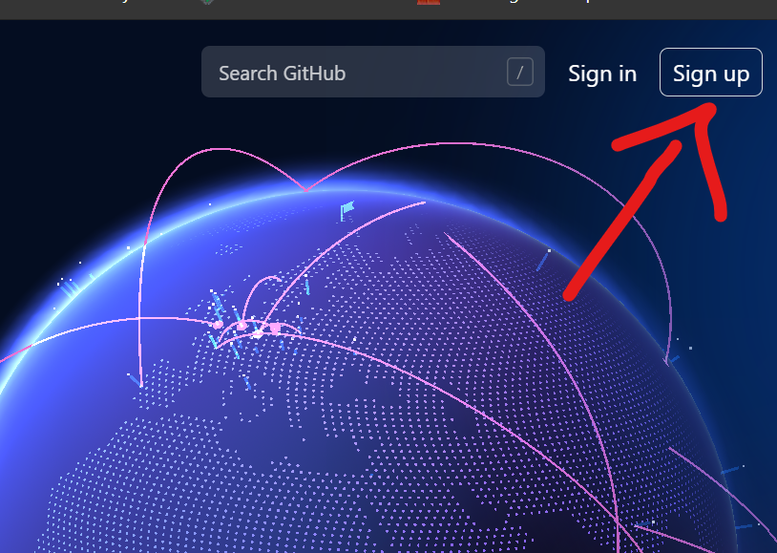

**Fill up your detail ::-**

**Username, Password, and Email:**

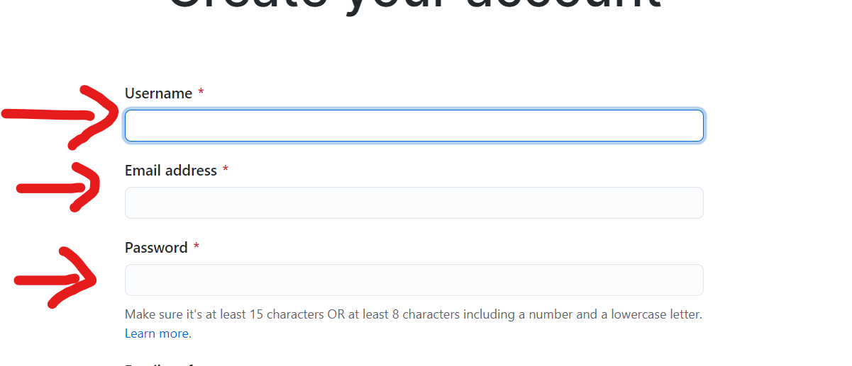

**Then verify the your email and click create account :**

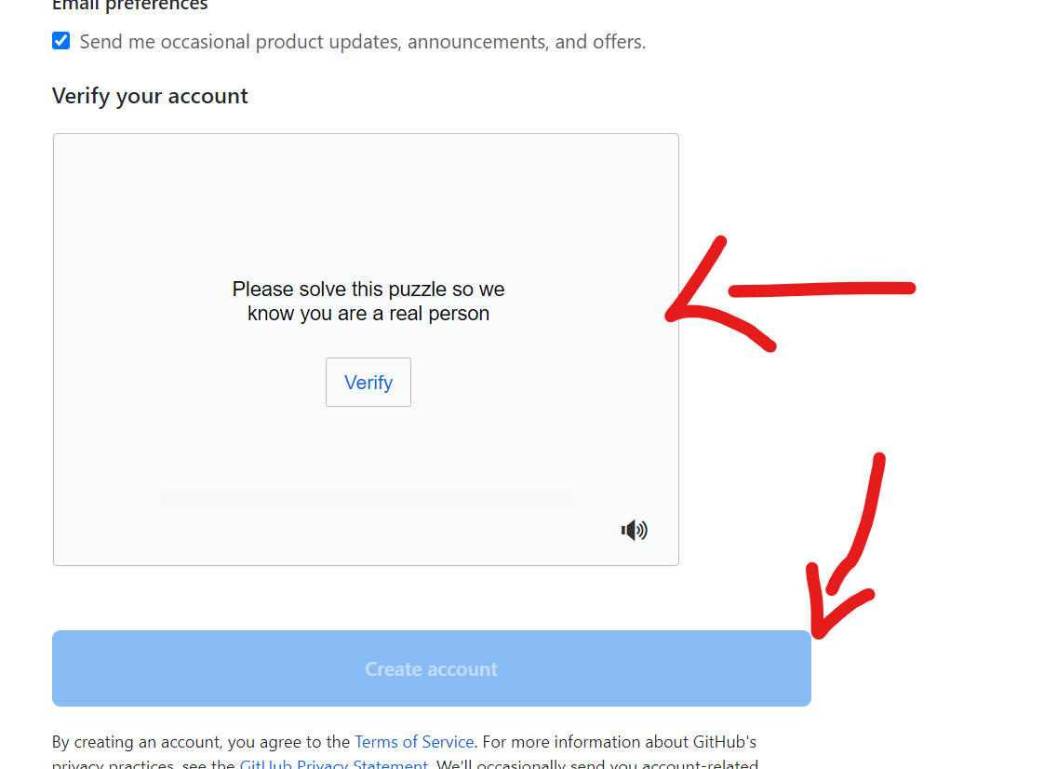

* **Select the occupation**



**b) Creating Repository :**

**Click on + sign and click on New repository**

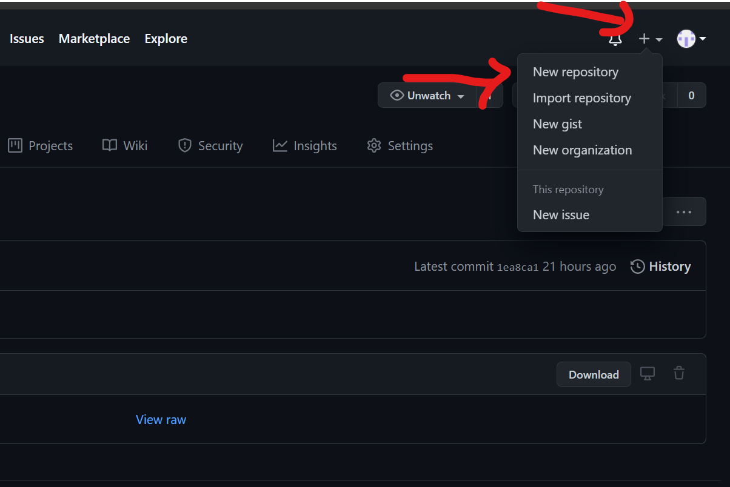

**Give Name to your repository and do the setting as per requried**

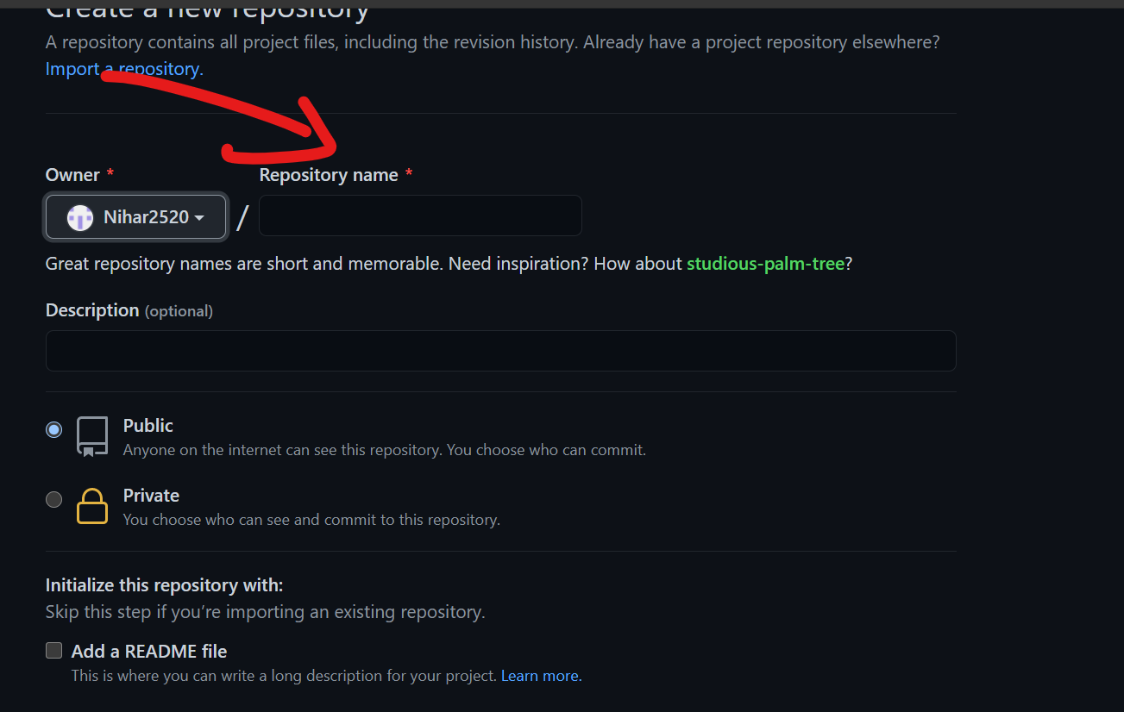

**c) Cloning repository:**

**Click on Code in green highlight as shown in screen shot:**

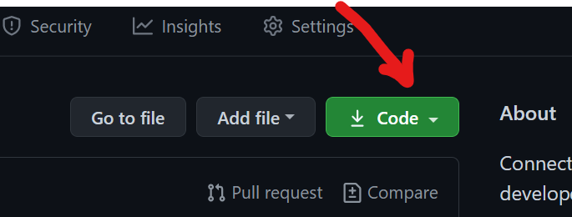

**You can clone it with three steps as HTTPS or SSH or GitHub CLI:**

